**Lesson11 Deploy Azure Batch Service**

**steps:**

**\*in order if we apply ffmpeg.exe on windows as told on Tools > Install ffmpeg on windows and add as enviroment variable then execute the following command**

**//(with add the ffmpeg folder in the same path of the enviroment variable)**

**//sample code (it will create new video called output.avi extension)**

**ffmpeg -i 1280.mp4 output.avi**

**//we will take the mp4 file and extract to audio file (just sound using the ffmpeg.exe)**

**ffmpeg -i 1280.mp4 -vn -acodec copy audio.aac**

steps:-

**1-we go to the following path (C:\ffmpeg\bin) and add to archive as ZIP format for ffmpeg.exe**

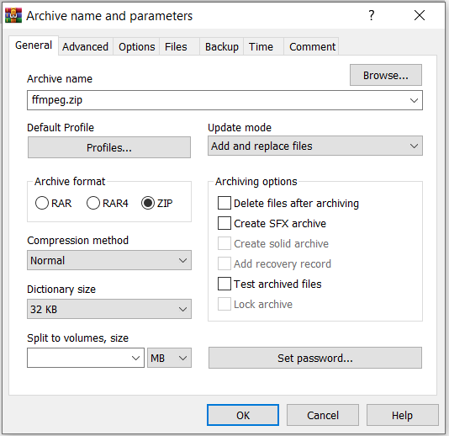

**3-on azure portal > create storage account**

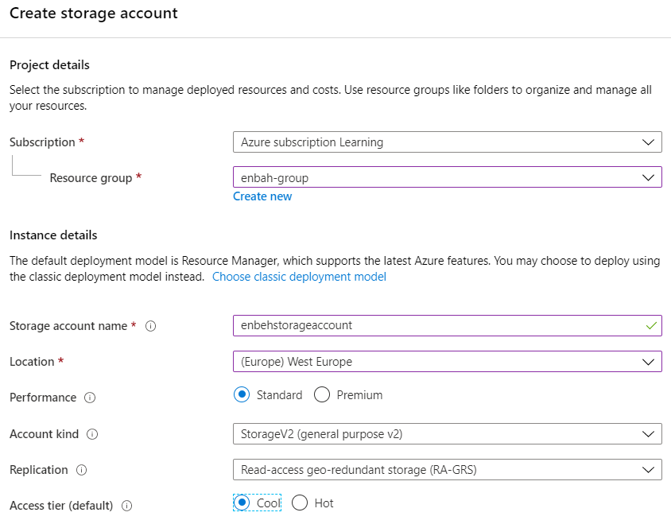

**4-on azure storage account > create 3 containers application , inputs , outputs**

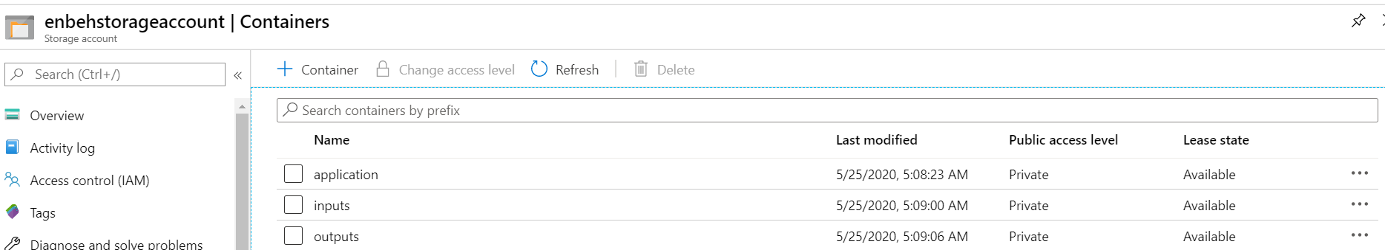

**5-create batch account and assign storage account to it**

**(on advanced tab we choose batch service to allow Azure batch service to control the Nodes (VM’S))**

**On advnaced tab we have two options**

**1-User subsription : in order to manage the VMS by your self**

**2-Batch servcies : in order to create batch servcie that will manage the VM by Azure**

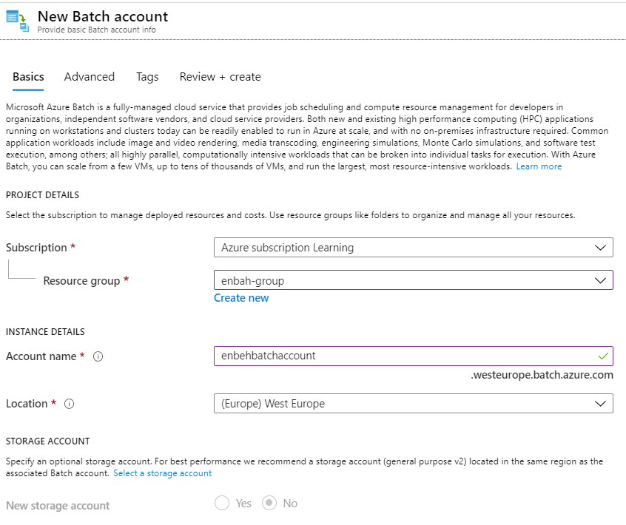

**6-on the Azure batch account > Application > add new application and attach the zip file of the ffmpeg**

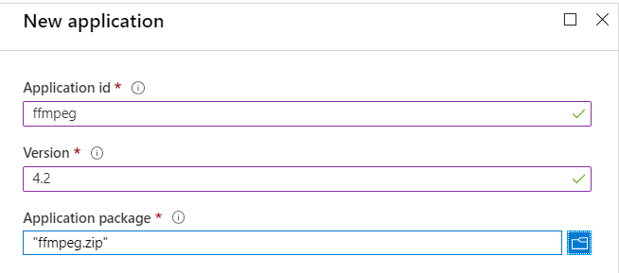

**7-on batch account > pool > add pool**

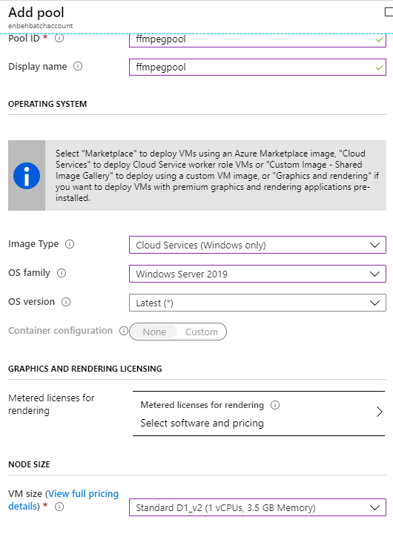

**(we set also dedicated nodes = 1 with set the nodes as Cloud servcies windows only with speicify the O.S and VM Type)**

8-on batch account > Job > create new Job with select the pool created with the batch service

The command we type is the following

**//it will say use this package called ffmpeg of version 4.2 and get the blob called 1280.mp4 and extract into voice of name audio.aac**

**cmd /c**

**%AZ_BATCH_APP_PACKAGE_ffmpeg#3%\\ffmpeg.exe -i 1280.mp4 -vn -acodec copy audio.aac**

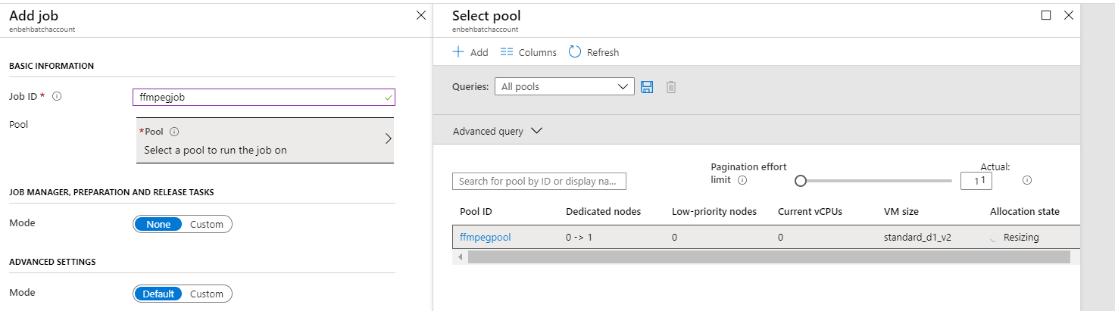

**We select the resources files by click on the container and include SASS key and select Input Containers that hold the blob 1280.mp4**

**8-we have to go to node and connect it and make sure that the enviroment variable is applied and add under C:\ffmpeg\bin with notify that the package name of version 3**